Workshop 6

Introduction
An Autonomous System is defined as a large network under the control of one company, e.g. the University network is seen as an autonomous system. The Internet consists of all these autonomous systems passing traffic into and/or through them and through this cooperation traffic will pass through one to another. In this lab you will configure two autonomous systems using eBGP for the Company and the ISP. The ISP will provide the default route to the Internet, with the notional webserver existing somewhere in the internet. Once configuration is complete you will use various show commands to verify that the EBGP configuration is working as expected. Finally you will perform a ping test to confirm this.

Topology
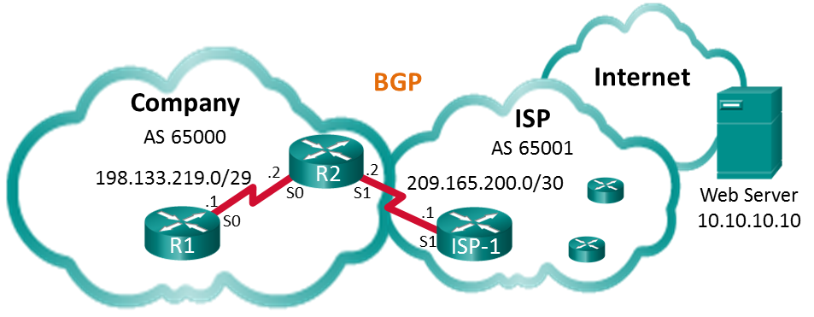

Objectives
Part 1: Build the Network and Configure Basic Device Settings
Part 2: Configure EBGP on R1
Part 3: Verify EBGP Configuration

Cable up the networks as shown in the diagram and configure the routers with the basic settings below

HostName | Interface | IP Address | Subnet Mask
R1 | S0/0/0 (DCE) | 198.133.219.1 | 255.255.255.248
R2 | S0/0/0 | 198.133.219.2 | 255.255.255.248
 | S0/0/1 (DCE) | 209.165.200.2 | 255.255.255.252
ISP-1 | S0/0/1 | 209.165.200.1 | 255.255.255.252
Web Server |  | 10.10.10.10 | 255.255.255.255

Further settings

ISP-1
A loopback address is a software address that is used for testing, in our case it will act as the webserver.
Configure a loopback address

Border Gateway Protocol is used as the routing protocol between Autonomous Systems. In our case the ISP has an AS number of 65001 and its neighbour, 65000 and we will enable BGP as a routing protocol and direct traffic to the neighbour AS 65001 via the link to it.
enable BGP
ISP-1(config)# ip route 0.0.0.0 0.0.0.0 Lo0
ISP-1(config)# router bgp 65001
ISP-1(config-router)# bgp log-neighbor-changes
ISP-1(config-router)# network 0.0.0.0
ISP-1(config-router)# neighbor 209.165.200.2 remote-as 65000
ISP-1(config-router)# end

R1
A static default route to the loopback address must be configured on R1, use a search engine to compose this command and then deploy it.
.

Router R2
Enable BGP, configure it so ISP-1 is the BGP peer, and advertise it’s network to ISP-1
R2(config)# router BGP 65000
R2(config-router)# neighbor 209.165.200.1 remote-as 65001
R2(config-router)# network 198.133.219.0 mask 255.255.255.248
Verify EBGP configuration
- Display the IPV4 routing table for R2 and examine the entry that relates to BGP
- Display the BGP table on R2 by using the ‘show IP bgp’ command
- Display the BGP connection status using the ‘show ip bgp summary’ command
- Ping the loopback address from router R1 to demonstrate you have been successful in your setup.

Portfolio Research tasks
- What is a loopback address and why is it used?
- What is an Autonomous system and what role does BGP have in their use?
- The University of Wolverhampton main site has an AS number, what is it?

